Boundary value

Intro

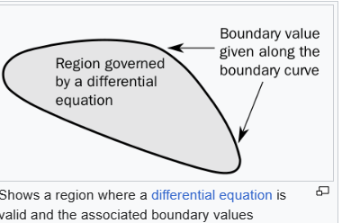

Type

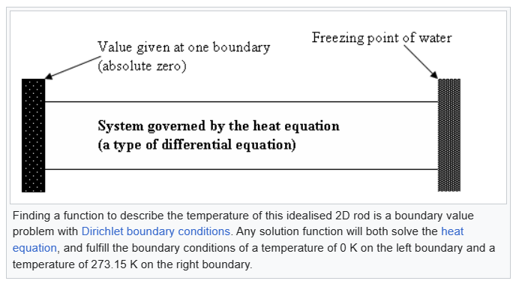

Ref

[Boundary value problem - Wikipedia](https://en.wikipedia.org/wiki/Boundary_value_problem)